

DYNAMICS TMS

Objectives:
- NEXTrack

Introduction:
Dynamics TMS and NEXTrack provides functionality and visibility by leveraging the Internet. NEXTrack is a combination of read only information or interactive functionality based on user roles. NEXTrack can also configured to provide carrier access to accept/reject loads, status update, freight bill entry.

HOME

Login page
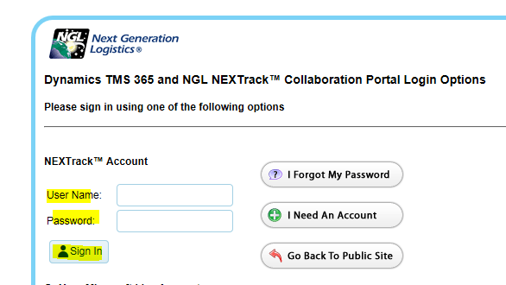

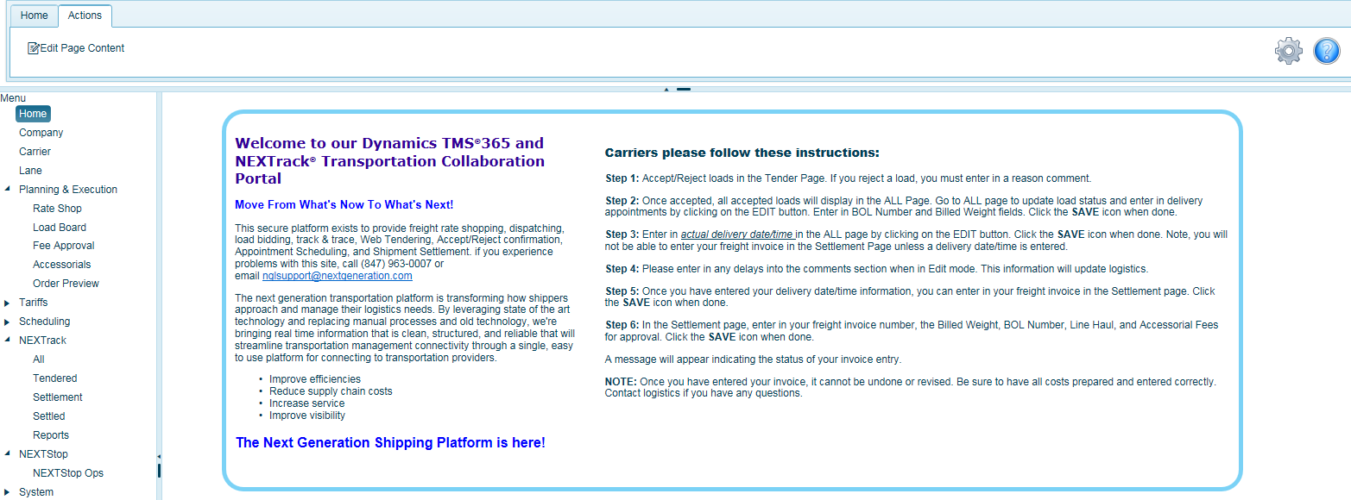
A BLUE question mark can be found on each page you are working on. Here users can store information and notes about a particular page and edit the content.


Click on the Pencil icon to edit. After entering in notes, be sure to click the save button. Entering notes by a specific user, will only be seen by that user. System Administrators can enter in system wide notes for all users.
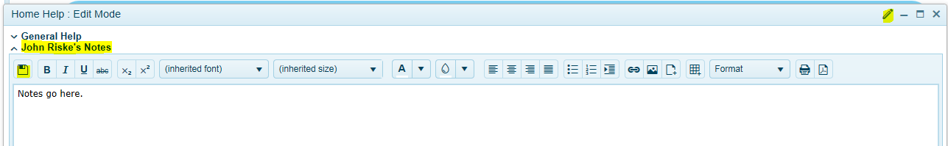
To change the column headers and select the data preferences to view, look for this icon to check on/off to display data. This is available anywhere you see this icon on a page.
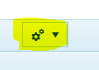

Home page
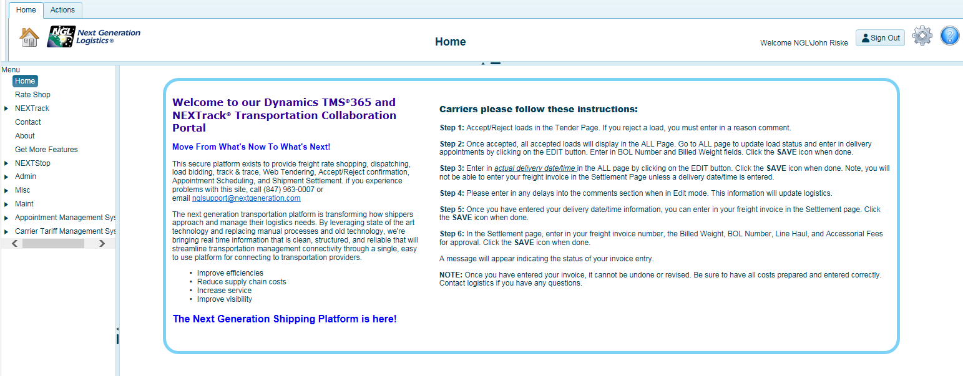

NEXTrack
Most user configurations will have access to NEXTrack and the pages contained within. By clicking the black arrow and expanding NEXTrack, you will see other pages accessible within NEXTrack.
The help screen will appear. Each user can add their own notes and procedures directly into this screen by clicking on the pencil icon to edit the help information. Click save when done. For example, if you click on the pencil icon, Peggy and can add her notes and procedures as reminders. Peggy will only see Peggy’s notes. All users will see ALL page Help.
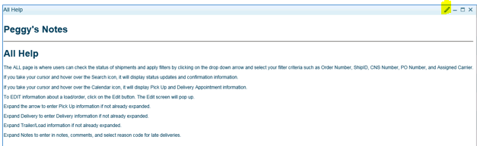

Expand the black arrow next to NEXTrack to review the pages according to your credentials.
- NEXTrack
- ALL (track and trace functions, search capability)
- Tendered (Typically for carriers and depending on carrier user credentials)
- Settlement (Typically for carriers and depending on carrier user credentials)
- Settled (Typically for carriers and depending on carrier user credentials)

All Page
This is where users can check the status of shipments and apply filters such as order number, ShipID, CNS Number, PO Number, and Assigned Carrier.
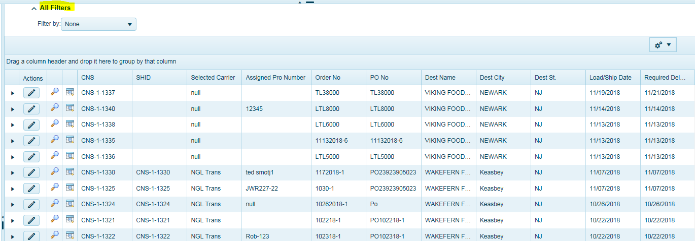

Users can apply filters to search for specific information. Use the drop-down list to apply filter criteria.
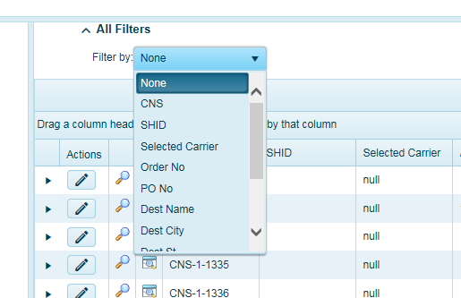
Hover your cursor over the magnifying glass to see all load status updates related to this order(load) whether the input is from EDI or carrier direct entry into the system.

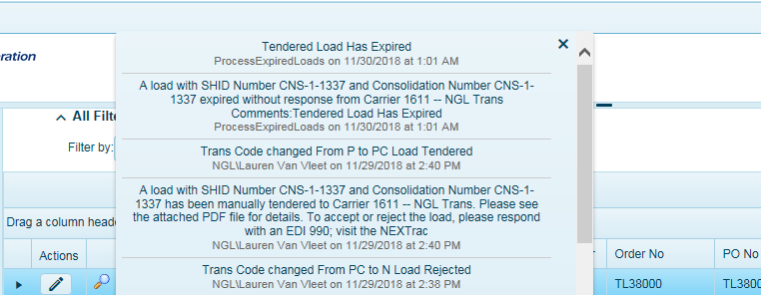

Hover your cursor over the Calendar icon to review appointment information.

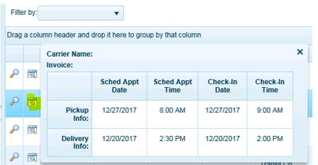
To see the items that are on this order, click on the black arrow to expand the page.
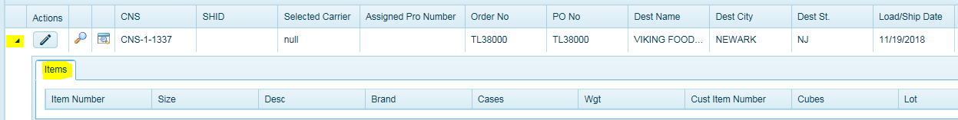

Edit-Data Entry
Click on the pencil icon to see or enter additional tracking fields such as Pick Up and Delivery appointment information, trailer number, seal number and more.
When using the scheduling system, the date and time will auto populate. The appointment fields will also be grayed out while using the scheduling system and once an appointment is created. This is to protect the appointment for use within the scheduling system and that no one can edit appointments when schedule is in use. Upon delivery, the fields will no longer be grayed out. Trailer/Load information is a manual input.
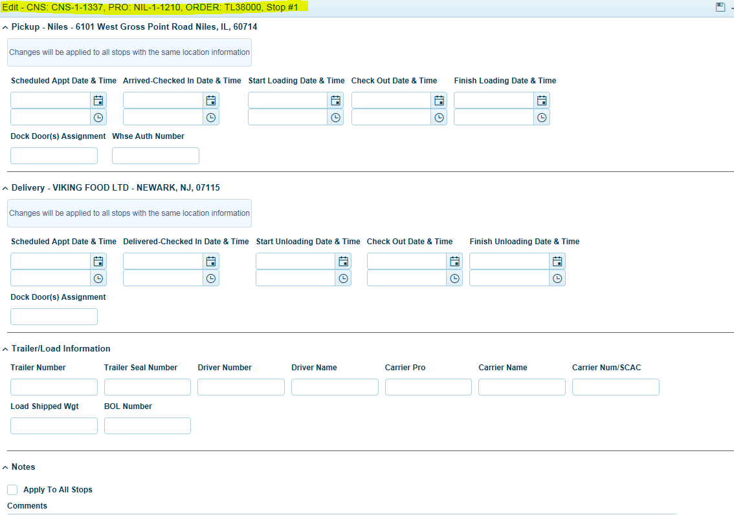

The Edit screen will pop up. Be sure to click the save icon in the upper right-hand corner of the screen to save entries.
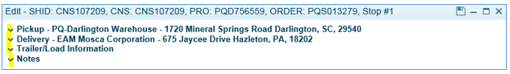
Click and expand the arrow (yellow highlight) to enter Pick Up information if not already expanded.
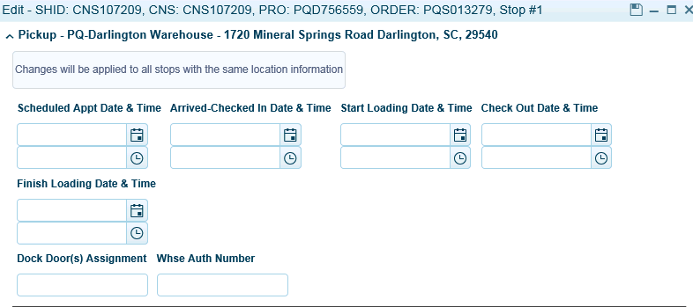
Click and expand arrow for Delivery to enter Delivery information if not already expanded. NOTE: Delivered-Checked In Date/Time is when the order/load actually delivered. This is the field that tracks on time performance as well as the field that needs to be populated for carriers to enter in freight bills.
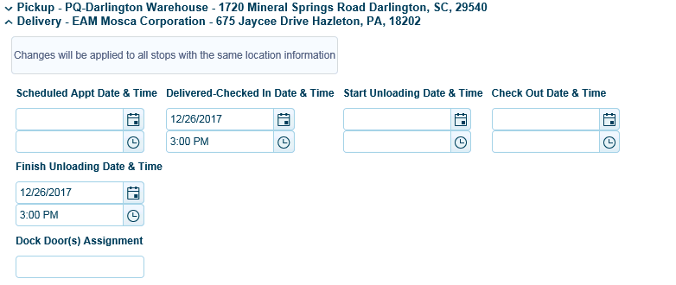
Click and expand Trailer/Load information if not already expanded to enter Trailer/Load information.
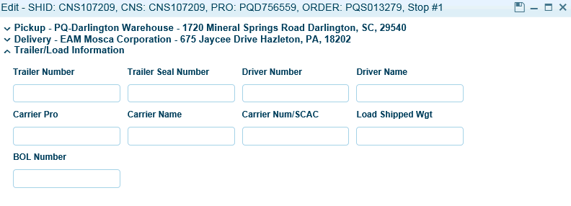
Click and expand Notes to enter in notes, comments, and select reason code for late deliveries. Once entered, this information is stored in the system for all users to view when they tract load status.
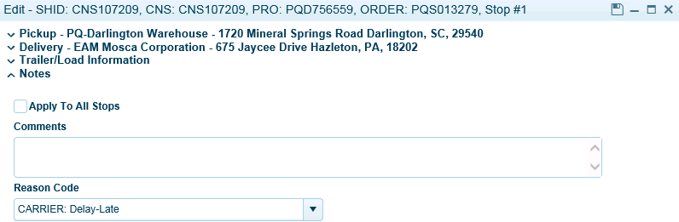

Settlement Page
The settlement page is where carriers will enter in their freight invoices and fees. Again, depending on credentials, not all carrier users or TMS users will have access to this page. Carrier users, who have been set up as accounting users, will have access to the Settlement and Settled Page for carriers to enter invoices.
The Settlement page allows carriers or TMS users to enter in freight invoices. We have two options and users should seek instructions on which option is best to use based on your implementation.
1) Quick Edit – This is used for quick entry of the Freight Invoice Number and Total Invoice Amount Only. Click Save when done.
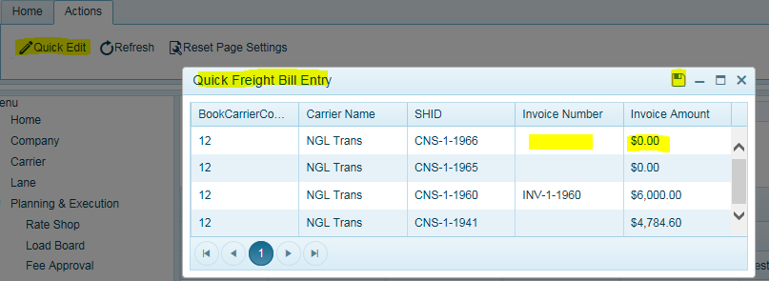
2) Detailed Freight Bill Entry-This is used to allow carriers/users to insert additional fees as part of their invoice and apply tolerances at the fee level.
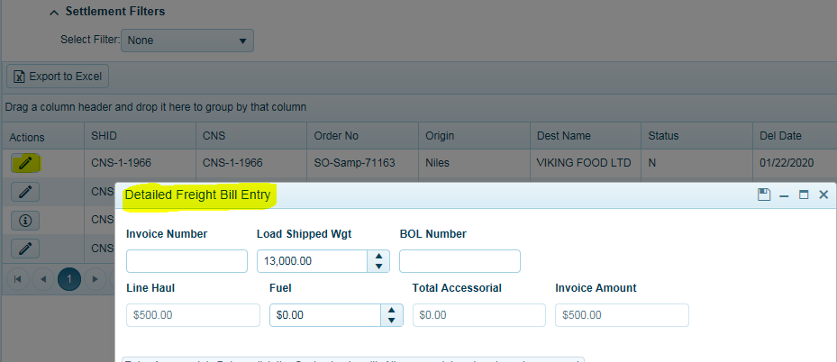

In order for carriers to see data and enter their freight invoice within the Settlement Page, they will be required to enter in a delivery date/time stamp in the ALL Page. Only loads with a delivery date will appear in the Settlement Page.
Carriers must enter in their invoice for each load (CNS / ShipID). Summary invoices are not allowed. In situations where carriers have a summary invoice for more than 1 load, they must append a -1, -2 or –A, -B at the end of their invoice entry to make this freight invoice unique.

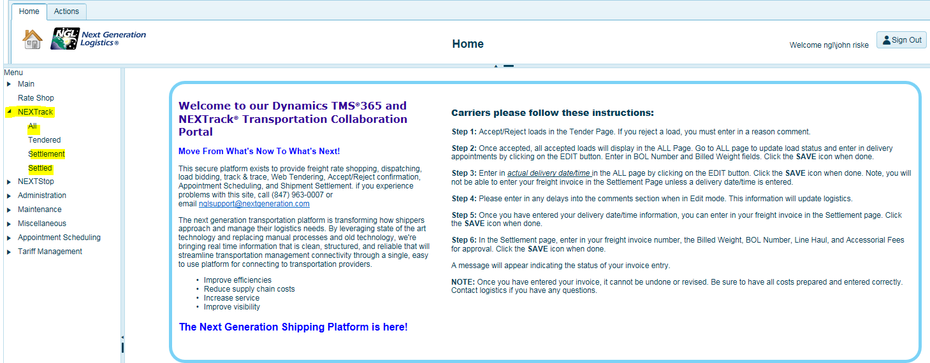
After the Delivered-Checked In Date/Time field has been populated, Click on Settlement to enter in your freight invoices.
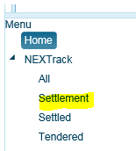
You can search for the CNS (aka ShipID) load you want to enter in your freight invoice for. Click on EDIT to insert your invoice.
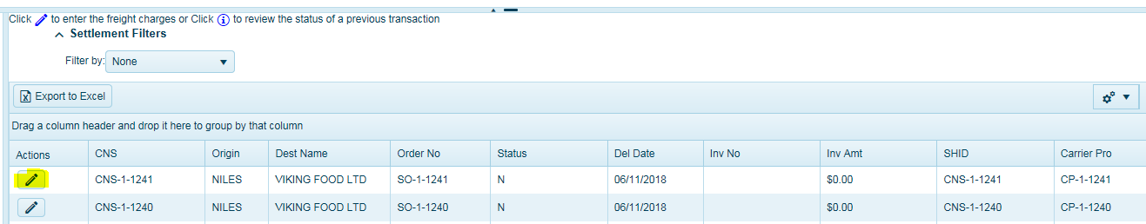
The Detailed Freight Bill Entry Screen will open. Yellow highlighted are required fields to be entered by carriers.
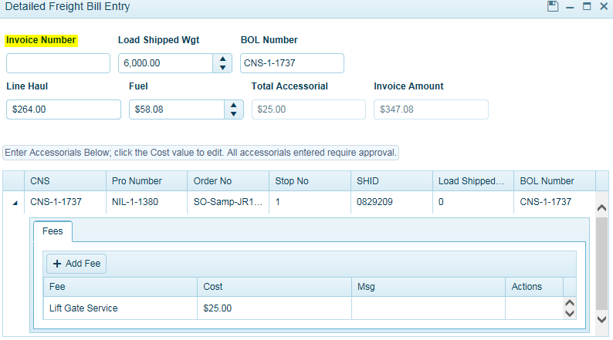

Carriers must enter in their Invoice Number. The Line Haul and fuel will autofill. The Fuel can be edited but not the Line Haul.
Once the invoice number has been entered, carriers can now enter in any fees associated with an invoice.
Click and expand the black arrow next to the CNS Number (ShipID) and click ADD FEE.
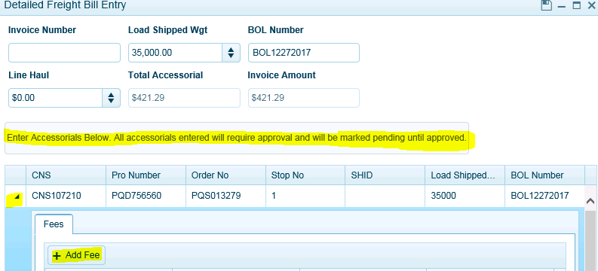
In most configurations, the fees will automatically display and be populated with the costing.
Select your appropriate fee that has been pre-configured and fee amount. Click Add Fee again to add additional fees.
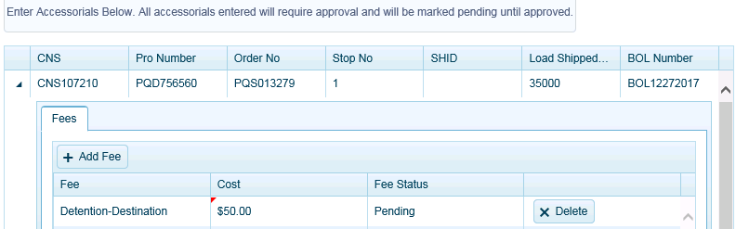
Click SAVE icon when done entering in fees. It is important to note that once fees have been entered and saved, the invoice process is complete, and carriers cannot change anything.
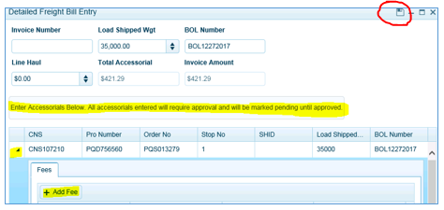
After entering in your invoice, fee, and clicking save. The system will update the status of the invoice based on the TMS configuration.
There are three statuses:
Approved = the system automatically approved the entry, passed audit, and will disappear from the screen. Setting the PExp (Pay Expense workflow to AA-auto approved) in the Load Detail Screen.
Pending Approval = the system accepted carrier entry and is waiting on TMS user approval. This transaction will remain in the Pending Approval Page until a user approves them.

The status will be updated in TMS on all loads that are Pending Approval (PA). Setting the PExp (Pay Expense workflow to PA-Pending Approval) in the Load Detail Screen.

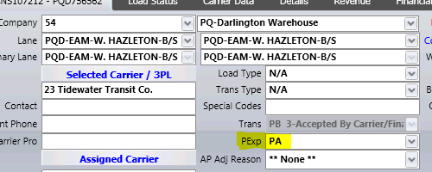

Failed = the system accepted the freight invoice entry as a matched transaction in TMS but has failed the audit process. Users should communicate with carriers and run Audit Report and to resolve the invoice. All transactions will need to be fixed, pass audit, and will automatically set to AA status.
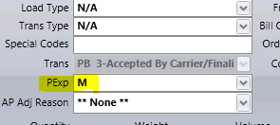

Settled Page
Carrier Users with Accounting credentials will only be allowed to access information on this page. The Settled Page will display all approved freight invoices waiting for payment update information from the ERP system (if configured). Carriers can view what invoices have been paid and what is outstanding.
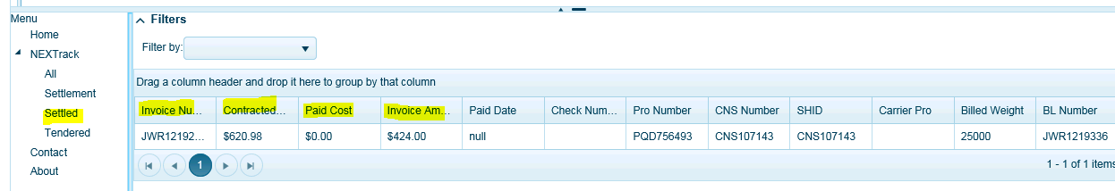

Tendered Page
This page will display all load tenders sent to each carrier by the logistics department. Carriers will only be able to see their own load tender information. Upon tendering by the logistics group, an email will be sent to the carrier indicating a load has been tendered to them and they should login and ACCEPT/REJECT the load. It is important to inform carriers that there is an expiration time for them to accept loads. A PDF tender sheet will be attached to the email. API carriers will not receive a tender email. Only carriers will have access to the Tendered page.
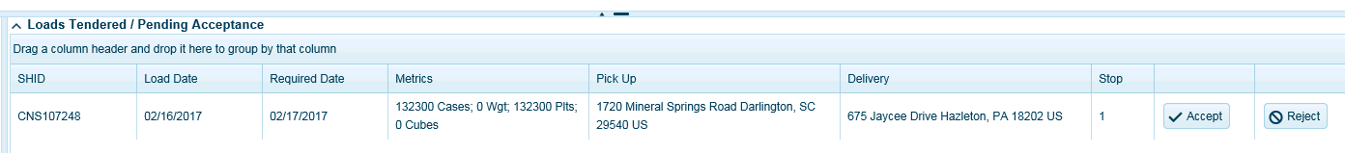
Accept Load – Load will successfully save and be removed from screen. Will now be available in the ALL Page for further updates.
Reject Load- If carrier rejects load, they’re required to enter reason-click save. This helps track carrier performance and reporting.
